Question 1:

#include <iostream>

using namespace std;

int main()

{

cout<<"Please enter the elements of the array: ";

int arr[20];

int size=0;

int ans=0;

for(int i=0;i<20;i++)

{

cin>>ans;

if(ans==-99)

break;

else

{

arr[i]=ans;

size++;

}

}

cout<<"\nThe original array is: ";

for(int i=0;i<size;i++)

{

cout<<arr[i]<<" ";

}

for(int i=0;i<size;i++)

{

for(int j=i+1;j<size;j++)

{

if(arr[i]>arr[j])

{

swap(arr[i],arr[j]);

}

}

}

cout<<"\nThe modified array is: ";

for(int i=0;i<size;i++)

{

cout<<arr[i]<<" ";

}

}

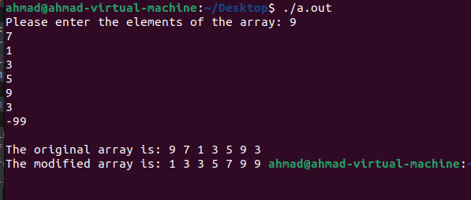

Wireshark:

What is the IP address and TCP port number used by your client computer (source) to transfer the file to gaia.cs.umass.edu?



Port is 80



IP is 192.168.1.102

What is the IP address and port number used by gaia.cs.umass.edu to receive the file

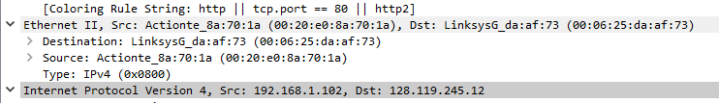

IP is 128.119.245.12



Port is 1161

What is the sequence number of the TCP SYN segment that is used to initiate the TCP connection between the client computer and gaia.cs.umass.edu? What is it in the segment that identifies the segment as a SYN segment?

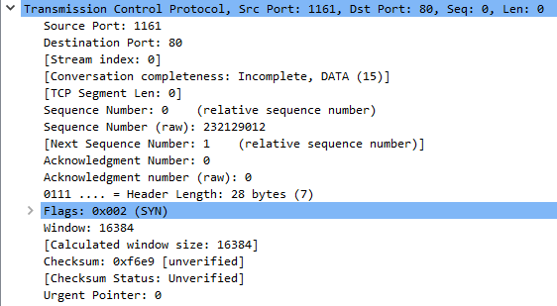

In the flags window the SYN flag is on



What is the length of each of the first six TCP segments



62+62+54+619+1514+60= 2371